**Ideation Phase**

**Define the Problem Statements**

|  |  |
| --- | --- |
| Date | 22 June 2024 |
| Team ID | SWTID1720195916 |
| Project Name | Stock Trading Web App |
| Maximum Marks | 3 Marks |

**Customer Problem Statement Template:**

**Problem 1:** How can we design and implement a robust stock trading web application using the MERN stack that ensures real-time data synchronization across multiple users and devices while maintaining high scalability and performance?

**Problem 2:** How can we ensure the security, privacy, and regulatory compliance of a stock trading web application built with the MERN stack, while providing a seamless and user-friendly experience?

**Example:**

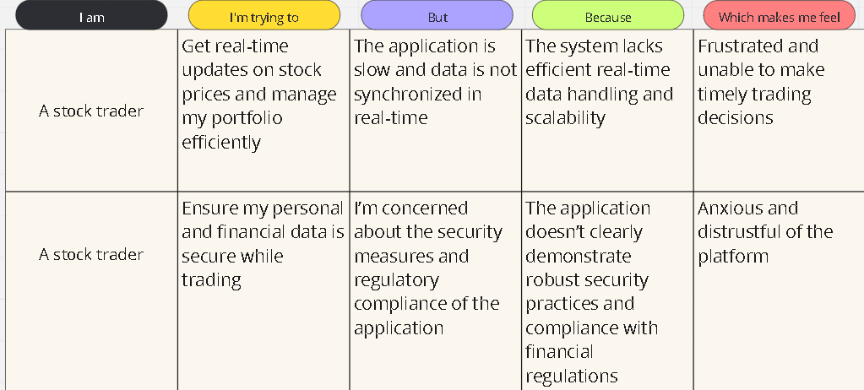

|  |  |  |  |  |  |
| --- | --- | --- | --- | --- | --- |
| **Problem Statement (PS)** | **I am (Customer)** | **I’m trying to** | **But** | **Because** | **Which makes me feel** |
| PS-1 | Ram (A stock trader) | Get real-time updates on stock prices and manage my portfolio efficiently | The application is slow and data is not synchronized in real-time | The system lacks efficient real-time data handling and scalability | Frustrated and unable to make timely trading decisions |
| PS-2 | Raju (A stock trader) | Ensure my personal and financial data is secure while trading | I’m concerned about the security measures and regulatory compliance of the application | The application doesn’t clearly demonstrate robust security practices and compliance with financial regulations | Anxious and distrustful of the platform |